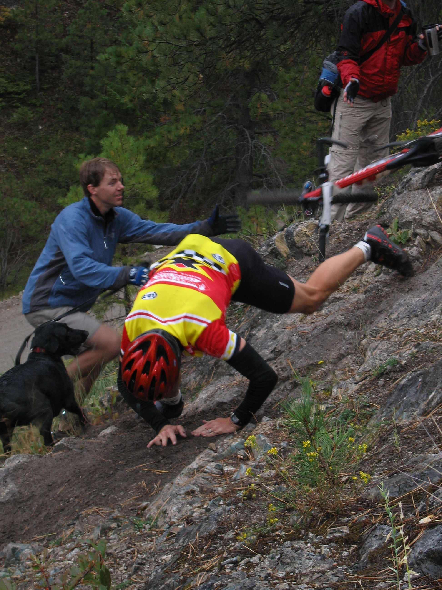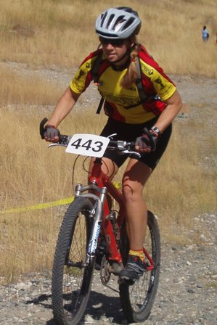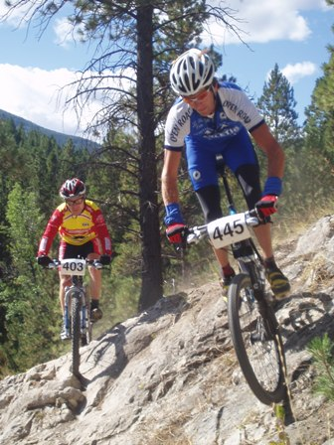
WERKS
Mountain Bike Race
Helena MT
Sunday September 9
$500 Dollars in giveaways for all finishers and cash for winning experts

Same great south hills cross country course
But this time we will run counter clock wise
4.5 miles of prime Helena trails 70% single track

Race Registration will start at 9AM, Racing starts at 11AM
Beginner 2 laps
Sport and Single speed 3 laps
Experts 5 laps

Entry fee is $20 + NORBA License
$15 for students + license

The start / finish area will be at the Davis St. Trail head,
2 miles south of the Broadway & Davis intersection.

Sponsored by
Great Divide Cycling Team
Great Divide Cyclery, Windbag Saloon, Taco del sol,
Blackfoot River Brewery, Bagel Co

For more info contact
Trever Brandt
Tabmt@juno.com
406-439-8547

